

NCICB

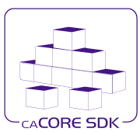
caCORE SDK
Generated System Detail Design

Version No: 0.2
Last Modified: 07/09/2007

Author: Satish Patel
Team: caCORE SDK
Client: National Cancer Institute - Center for Bioinformatics,
National Institutes of Health,
US Department of Health and Human Services

This document was prepared NCI Center for Bioinformatics
Pursuant to the caCORE Software Development Kit (SDK)
Project (REF: Solicitation No. S06-234).

Document History

Document Location
The most current version of this document is located in CVS under cacoresdk/Project/SDK _v3.2.1_4.0/Development/Design.

Revision History
Version Number | Revision Date | Author | Summary of Changes
0.1 | 07/06/07 | Satish Patel | Initial draft
0.2 | 07/09/07 | Satish Patel | Incorporated comments from the review

Review
Name | Team/Role | Version | Date Reviewed | Reviewer Comments
Kunal Modi, Charles Griffin | CSM/Lead  SDK/Manager | 0.1 | 07/09/07

Related Documents
More information can be found in the following related documents:

Document Name

Table of Contents
Document History 2
0.1 Document Location 2
0.2 Revision History 2
0.3 Review 2
0.4 Related Documents 2
Table of Contents 3
Table of Figures 4
1. Introduction 5
1.1 Purpose 5
1.2 Intended Audience 5
1.3 Scope 5
1.4 Overview 5
1.5 Definitions, Acronyms, and Abbreviations 5
2. Technical Overview 6
2.1 High-level Architecture 6
2.1.1 n-tier system 6
2.1.2 Persistence Tier 7
2.1.3 Application Service Tier 8
2.1.4 Security Interception Tier 9
2.1.5 Client Interface Tier 10
2.1.6 XML-HTTP Client 10
2.1.7 Web Services Client 10
2.1.8 Java API Client 10

Table of Figures

Figure 1: SDK Generated System Architecture 6
Figure 2: Persistence Tier Classes 7
Figure 3: Application Service 8
Figure 4: Extending Application Service 9
Figure 5: Expected Behavior of SDK Generated Application 11
Figure 6: Actual Behavior of the SDK Generated Application - 1 12
Figure 7: Actual Behavior of the SDK Generated Application - 2 13

Introduction

Purpose
The purpose of this document is to describe the architecture of the generated system for the caCORE SDK code generator. The information in this document is to help the developers and the architects to help understand the inside working of the SDK.

Intended Audience
The intended audience for this document includes Developers and Technical Architects interested in the obtaining an overview of the generated system.

Scope
The scope of this document is limited to a discussion of proposed caCORE SDK generated system design and architecture. It also briefly describes the implementation of the other components of the system like queries and security.

Discussion about the previous implementation of the SDK’s generated system and how to migrate the users from SDK 3.2 to SDK 4.0 is beyond the scope of this document.

Discussion about topics like alternative approaches to implement the system, performance, how to use the generated system and future enhancements are beyond the scope of this document.

Overview
The following sections provide technical overview on the generated system with emphasis on the client server communication

Definitions, Acronyms, and Abbreviations
All definitions, acronyms, and abbreviations are provided in the centralized definition document found at cacoresdk/Project/SDK v3.2/Miscellaneous/Acronyms.doc.

Technical Overview

This chapter describes the architecture of the caCORE system. It includes information about the major components, such as security, logging, database object-relational mappings (ORM), client-server communication, and how the system connects to non- ORM systems.

High-level Architecture
The caCORE SDK generated system’s infrastructure exhibits an n-tiered architecture with client interfaces, server components, backend objects, data sources, and additional backend systems. This n-tiered system divides tasks or requests among different servers and data stores. This isolates the client from the details of where and how data is retrieved from different data stores. The system also performs common tasks such as logging and provides different levels of security. Clients (browsers, applications) receive information from backend objects. Java applications also communicate with backend objects via domain objects packaged within the client.jar. Non-Java applications can communicate via SOAP (Simple Object Access Protocol). Back-end objects communicate directly with data sources, either relational databases (using Hibernate) or non-relational systems (using, for example, the Java RMI API).

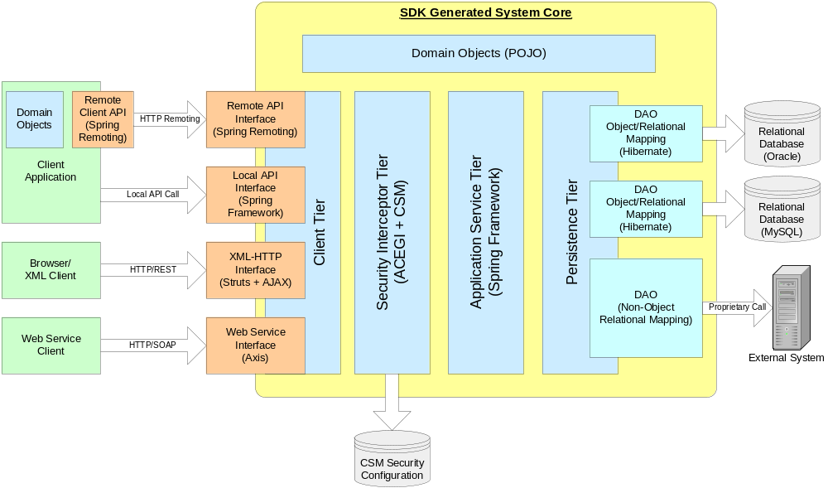
Figure 1: SDK Generated System Architecture

n-tier system
The SDK generated system is just like a typical n-tier architecture system. Each tier in the n-tier system is responsible for a set of defined activities. In SDK generated system, the layers starting from the lowest layer are as following

Persistence Tier
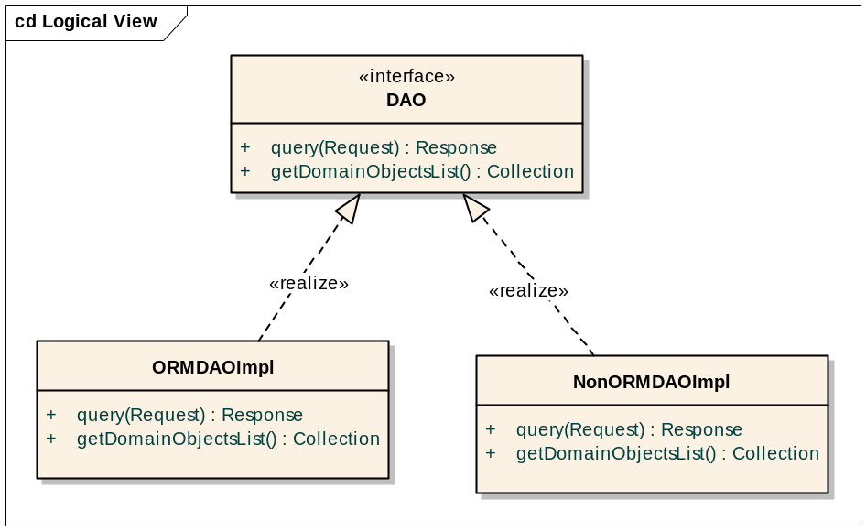
Figure 2: Persistence Tier Classes

The persistence tier is responsible for understanding the query that user has sent and fetching the results corresponding to the query. SDK currently supports persistence tiers created in two ways; object-relational mapping (ORM) based persistence tier and non-object-relational mapping (Non ORM) based persistence tier. For the user of the object-relational mapping based mechanism to access the data stored in the persistence tier, SDK provides a pre-constructed DAO (ORMDAOImpl). However, the users of the Non ORM based persistence tier, the users have to create a DAO (e.g. NonORMDAOImpl) which can understand the query sent by the user and fetch results in the form of the domain objects. Each DAO also provides a list of the domain objects when the Application Service tier asks for it by using the getDomainObjectsList method of the DAO. If the Application Service tier determines that there is an overlap between the lists of domain objects provided by the DAOs then the application will not be loaded. More details on how each DAO works is in the subsections 2.1.2.1 and 2.1.2.2.

      - Object Relational Mapping
SDK code generator performs the object relational mapping using Hibernate as underlying technology. Hibernate allows the objects to be mapped to the relational database by means of object relational mapping (ORM) files. These ORM files are generated by the caCORE SDK during the code generation process. If the user intends to not to use one or all of the mapping files and provide the mapping files developed by himself then he can do so by altering the code generation process. Alteration of the code generation process can be done through the configuration files and is explained in the later section.

      - Non-Object Relational Mapping
SDK users can choose to not to use the ORM as a way to map the relational database to the objects or the data for the objects reside on the remote server. In this scenario, the onus of populating the objects based on the query is on the user of the SDK. The user will have to develop a custom Non ORM DAO which can perform the task of retrieving the data. The custom Non ORM DAO is required to implement the interface expected by the caCORE SDK. Other than supporting the method to retrieve results using query, the Non-ORM DAO needs to implements another required method (getDomainObjectsList) which can return a list of the domain objects supported by that DAO.

Application Service Tier
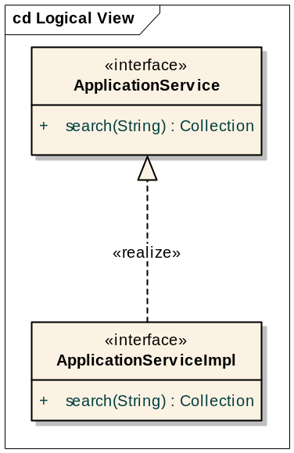
Figure 3: Application Service
Application service tier consolidates incoming requests from the various interfaces and forwards them to the appropriate persistence tier implementation. This is the main tier which facilitates the operations within the SDK generated system. The methods in the ApplicationService interface are the one that are exposed to the Java Clients. ApplicationServiceImpl class has the concrete implementation of the ApplicationService interface. When any of the four clients interface in the SDK code requests a handle to the ApplicationService, the default implementation of ApplicationServiceImpl is returned. When the remote Java client requests a handle to the ApplicationService, a remote handle to the ApplicationService is wrapped inside the ApplicationServiceProxy and returned to the client.

      - ORM System
The default Application Service tier has methods to support ORM based system. The methods are sufficient to support requirements for most applications. If the user intends to add additional methods in the Application Service tier then details can be found in the following subsections.

      - Non-ORM System
The user of the Non-ORM system may require a specific type of query to be used then in that case, the existing Application Service tier will not be enough and will need to be extended. If the Application Service tier is extended then all the configuration files which use the Application Service tier will have to be modified to reflect the changes. Depending on the need of the custom application to expose the custom query methods to the respective tiers, individual presentation tier will also have to be modified. For e.g. Java API interface will need to be changed to support lazy loading on the additional methods, web service tier will need to be modified to support additional query methods as part of the service.

      - Extending Application Service

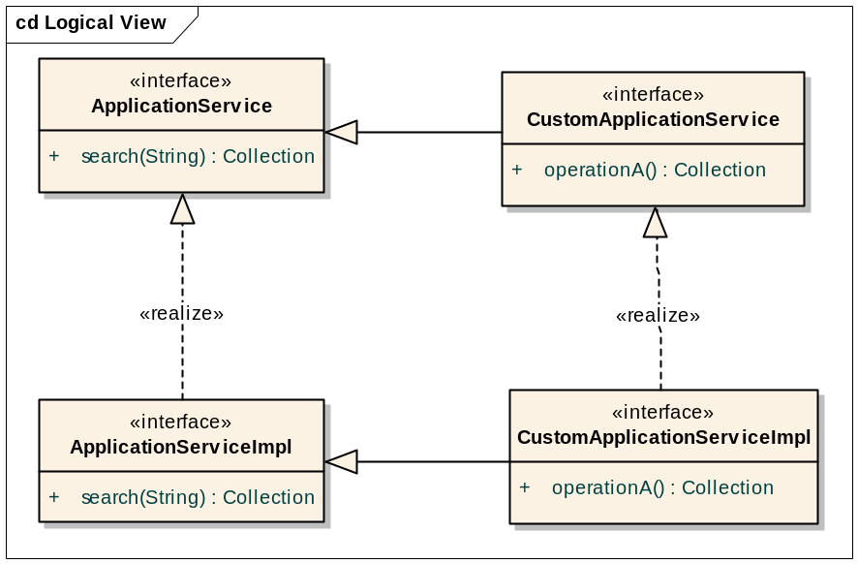
Figure 4: Extending Application Service

The default Application Service tier has methods to support ORM based system If the user intends to add additional methods in the Application Service tier then one of the possible approaches is to modify the source code to add additional methods; another option is to extend the Application Service and modify the configuration files to work with the extended Application Service. As shown in the Figure 4, a CustomApplicationService can extend the ApplicationService interface and CustomApplicationServiceImpl class provides a concrete implementation of the method inside the CustomApplicationService interface. As the new methods are added to the Application Service, client tiers will also be needed to be modified to expose the additional methods to their respective clients. The configuration files on the client and the server side will need to be modified to reflect the extension of the ApplicationService.

Security Interception Tier
This tier ensures that only the authorized users are allowed to access the system. The security configuration in the SDK is done using the ACEGI and Common Security Module (CSM) developed by NCICB. In the case of the unsecured system, this layer is disabled through the configuration files. <<More Details>>

Client Interface Tier
SDK provides four distinct ways to reach the Application Service Tier. Each of these four methods to retrieving data involves preparing the query in the format that the interface understands, sending the request to the corresponding interface, and retrieving the results from the interface to which the query was submitted earlier. Details about the system usage can be found in the next sections.
  - XML-HTTP Interface (browsers, thin clients)
  - Web Services Client
  - Local Java API Client
  - Remote Java API Client

XML-HTTP Client
The user of the XML-HTTP interface can access the data using two types of the clients 1) Browser to see data in the form of a web page and 2) Thin client to get XML data. The clients can form a query using query by example syntax and they are provided data for the result object. If client intends to fetch data for the associated object then the client is required to make a second query. In the browser, the client can click on the link to fetch the associated object while using the thin client, the client application is required to form the query to fetch the associated object and send it to the server. <<More Details>>

Web Services Client
The clients of the web service use the SOAP protocol to fetch the data. The clients connect to the SDK generated web services and send query to obtain the data. Since the web services are based on the WSDL, the client application can choose to generate the stubs corresponding to the domain objects of the application. This way the client application will get the data serialized in the form of the domain objects and not the XML. Web services is also a powerful way of querying the SDK as it allows clients developed in any programming language (which supports web services) to query to SDK generated system. <<More Details>>

Java API Client
The user of the Java API interface can access the SDK generated application using two different mechanisms. 1) Remote client server API call and 2) Local API call. Regardless of what type of communication strategy the Java client application chooses, the interaction of the client application remains the same. Typical client communication with the SDK generated application is illustrated below.
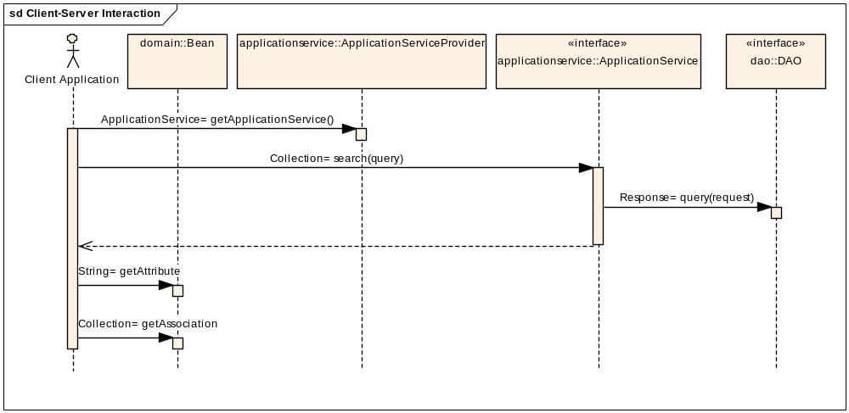
Figure 5: Expected Behavior of SDK Generated Application

The client of the generated application intends to fetch data from the database and use the data in the desired manner in their respective application. The client application intends to achieve this behavior by following the steps below.
- Obtain a reference to the service which can deliver the data
- Form the query and search the database using the prepared query on the service obtained in step 1
- Iterate through the result and obtain attributes/associations of the result object

If the client application is using the generated system in remote client server mode then in that case the generated client will need to connect to the remote service using the remote client. On the other hand, if the client application intends to use the generated system locally then it needs the service present in the local environment and remote calls should be avoided. Since the client application is developed in a different environment, it is better to isolate the client from knowledge about what type of client is used to fetch the data i.e. local client vs. remote client.

      - Technical Challenges
There are many ways to implement the expected behavior. The choices from the technologies front includes 1) Java RMI 2) Web Services 3) EJB 4) CORBA 5) Remoting etc. From the client perspective it is least relevant which technology is adopted to solve the problem of the client server communication. Another problem is how to fetch large result set and associated objects. Regardless of which technology is used to implement the application framework, the problem of loading the large result set and associated object remains. In order to resolve these problems, the data is required to be loaded on demand (lazy-loading). In order to lazy-load the objects, the developed application framework has to recognize the event when the remaining objects are to be loaded from the database. The events which require lazy loading are 1) Iterating through the large result set and, 2) Accessing attributes/associations of the retrieved objects.
The retrieved objects are required to trigger the event whenever the client application makes an attempt to access the attribute/association of that object. One possible way to achieve this functionality is to hardwire the event triggers in the result objects. This approach makes the result objects tied to the SDK generated application. Another way to achieve the same functionality is to dynamically inject the event triggers in the result objects. Following subsection describes how lazy-loading behavior is achieved in SDK.

      - Dynamic Proxy Based SDK Generated Client API

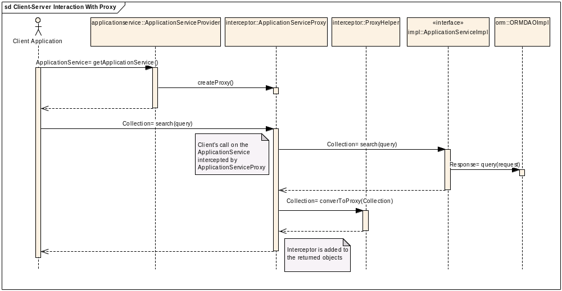
Figure 6: Actual Behavior of the SDK Generated Application - 1

In order for the client application to obtain the handle to the service tier (Application Service) of the generated application, SDK provides a helper class called ApplicationServiceProvider (ASP). ASP instantiates the service based on the settings in the configuration file (application-config.xml). The sequence diagram (Figure 6) shown above demonstrates how ASP retrieves the service. When the client application requests a handle to the service, ASP retrieves the handle to the service using the configuration file and adds an interceptor to the service resulting in ApplicationServiceProxy. ApplicationServiceProxy is a dynamic proxy generated using the AOP feature of the Spring Framework. ApplicationServiceProxy intercepts all the calls to the actual ApplicationService and takes action to facilitate the lazy-loading mechanism described earlier. At this time, the client application is expecting a handle to the ApplicationService to be received from ASP but they will receive ApplicationServiceProxy.

When client application makes a call to the ApplicationService, at that time, ApplicationServiceProxy will intercept the call and execute it. After the invocation made by the client on the ApplicationService, the ApplicationServiceProxy obtains the result from the actual ApplicationService. The obtained result set can be primitive objects of Java, domain objects or Java collections. Since domain objects or collection of domain objects can require to lazily load its associated objects, ApplicationServiceProxy is required to add an interceptor on the domain objects. After obtaining the results from the ApplicationService, the ApplicationServiceProxy uses ProxyHelper class to add appropriate interceptor (BeanProxy) to the domain objects so that the domain objects can trigger the event to lazily load attribute/associated objects.

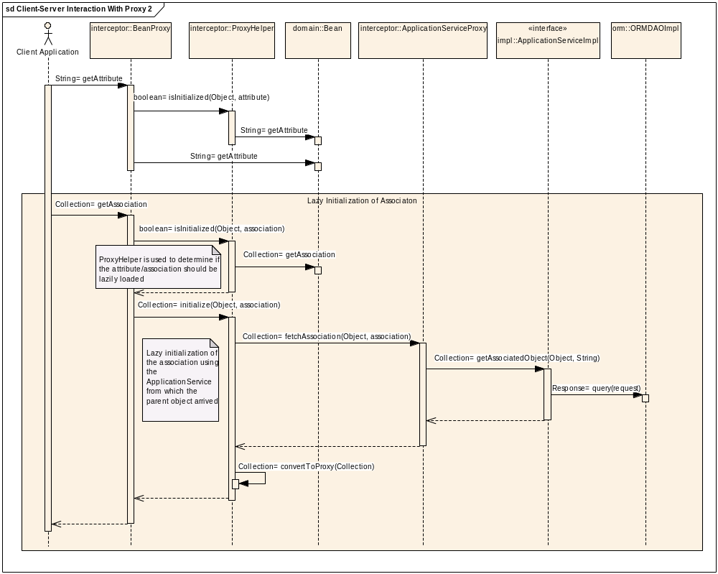
Figure 7: Actual Behavior of the SDK Generated Application - 2

The results returned from the ApplicationServiceProxy to the client application the result objects will have an added interceptor (BeanProxy). The interceptor holds a reference to the ApplicationService where the result objects were loaded from. When the client application invokes on any of the methods on the result objects to retrieve attribute/association then the interceptor (BeanProxy) of the domain object triggers an event. In wake of this event, the ProxyHelper class is being used as a decision maker to determine if the attribute/association should be lazily loaded. If the ProxyHelper class indicates that the method should be lazily loaded (i.e. the method should not be executed locally and ApplicationService should be used to obtain the return value) then in that case BeanProxy again uses ProxyHelper to execute the method and load the result from the correct Application Service.

For the ORM based applications, the ProxyHelper class will always check for the presence of HibernateProxy for the associations. If the HibernateProxy is present instead of actual associated object then in that case the ApplicationService is being called (via ApplicationServiceProxy) to fetch the associated object. The ProxyHelper is responsible for preparing the query and call the ApplicationService with appropriate parameters. For a Non-ORM system, the ApplicationService may have been extended to support additional query methods and these methods can return the domain objects that are not same as regular POJOs. In that case, the implementer of the Non-ORM system will need to intercept all the method calls to the result objects and resolve the lazy initialization routine. The Non-ORM system can configure the custom ProxyHelper through the configuration file (application-config.xml)

      - Using Client Application Framework to Connect to Multiple Remote Application Services
The client application framework can be used to connect to multiple application services at the same time. i.e. the client can connect to various SDK generated services at the same time using the same framework. Note that this feature can be used only with the remote client and not with the local client API. In order to facilitate this feature, the ApplicationServiceProvider (ASP) class is used in conjunction with the proxy framework mentioned earlier. ASP reads information from the application-config.xml to create a new instance of the Application Service. If the client application does not mention the service it needs to connect to, then in that case the ASP initializes the service described under the “ServiceInfo” bean in the configuration file. However, if the client application mentions the name of the service then ASP locates the configuration entry for that service, instantiates the service handler and returns it to the client after adding the interceptor. When using the client framework in the multiple services mode, the developer of the client application has to make sure of the following
- Domain objects corresponding to all the services it is trying to connect must be present in the local environment.
- The services to which the client application intends to connect should be based on the ApplicationService interface of the SDK core.
- The remote services can be an extension of the ApplicationService interface provided by the SDK. If one or more services have the same extension interface name (e.g. com.xyz..CustomService) then they should have the same method signatures as well.
- All the extensions of the ApplicationService interface corresponding to different remote services should be present in the local environment
- If any of the remote service has modified the ApplicationService interface then the client framework will fail to operate.
- Appropriate entries should be made in the application-config.xml for each of the remote services

http://www.hibernate.org
http://www.SpringFramework.org

